1. **customer_seq_table**

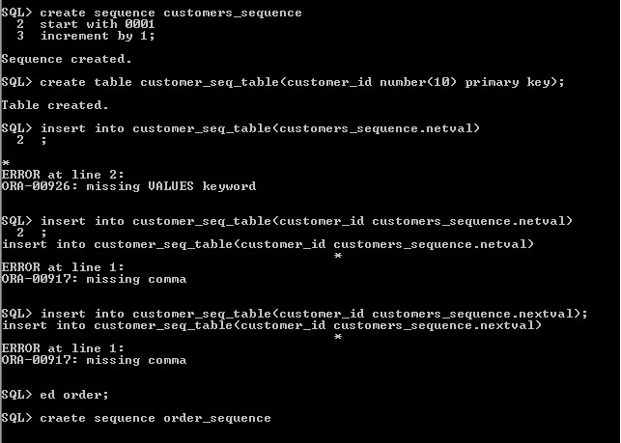

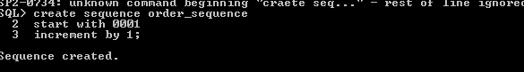

1. **customer_orders**

create table customer_orders(

customer_id number(10),

order_id number(10) primary key,

order_negotiation_date date,

order_due_date date,

order_status varchar2(30),

order_completion_date date,

order_xml varchar2(4000),

order_type varchar2(20),

foreign key(customer_id) references customer_seq_table(customer_id)

);

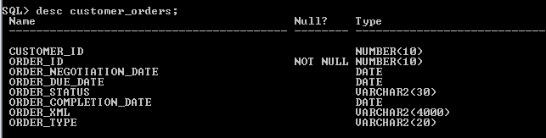



3**) customer_address**

create table customer_address

( address_id number(10) primary key,

add_line1 varchar2(30),

add_line2 varchar2(30),

city varchar2(20),

state varchar2(20),

state_code varchar2(10),

zip_code number(10)

);

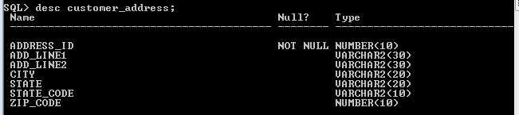

1. **customer**

create table customer

( customer_id number(10),

foreign key(customer_id) references customer_seq_table(customer_id),

customer_fname varchar2(30),

customer_lname varchar2(30),

customer_email_id varchar2(30),

customer_mobile_no number(15),

customer_status varchar2(15),

customer_type varchar2(15),

billing_address_id number(10),

foreign key(billing_address_id) references customer_address(address_id),

service_address_id number(10),

foreign key(service_address_id) references customer_address(address_id),

bill_payment_method varchar2(15)

);

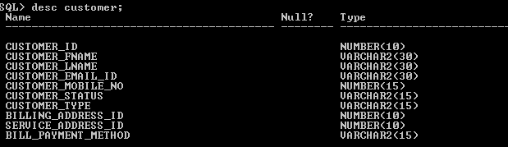

1. **product_services**

create table product_services

(

order_id number(10)

references customer_orders(order_id),

service_id varchar2(1),

product_id varchar2(10),

product_quantity number(5),

product_description varchar2(30),

product_start_date date,

product_end_date date);

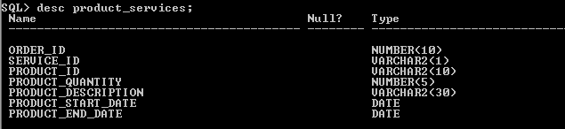

1. **customer_services**

create table customer_services

(

customer_id number(10)

references customer_seq_table(customer_id),

service_id varchar2(1),

service_current_status varchar2(20),

service_effective_date date,

service_end_date date);

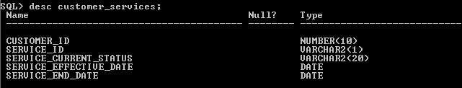

1. **service_description:**

create table service_description(

service_id varchar2(1),

service_name varchar2(20));

